AWS Load balancer lab Using classic load balancer.

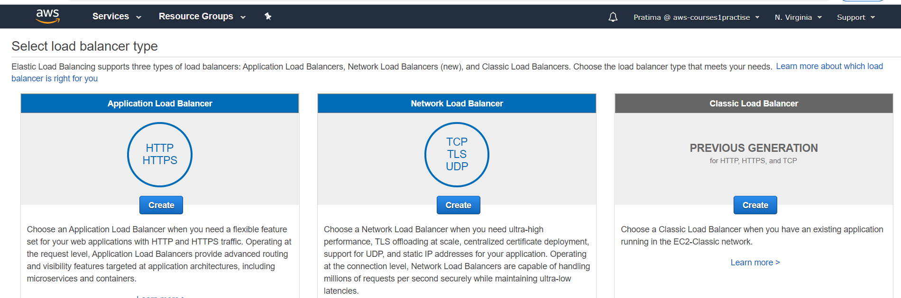

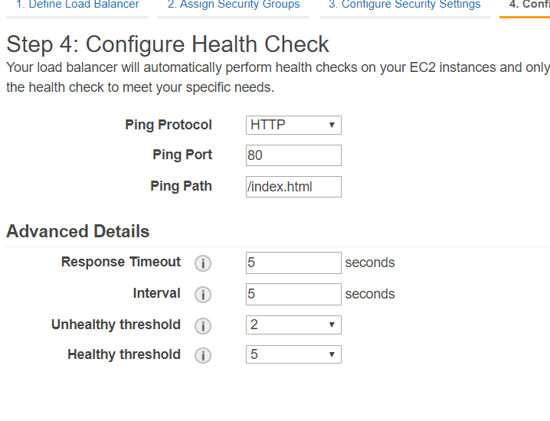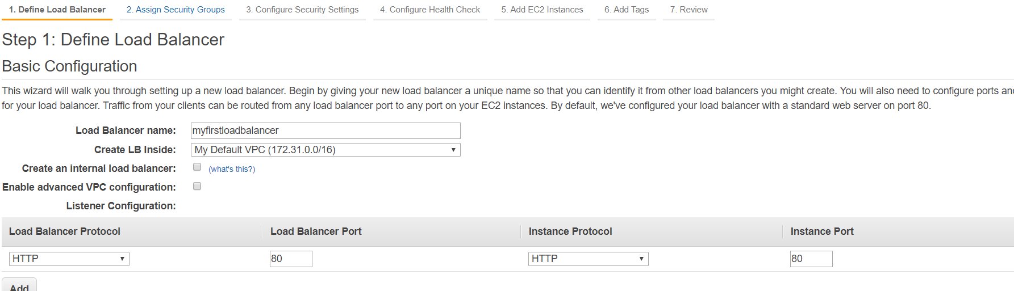

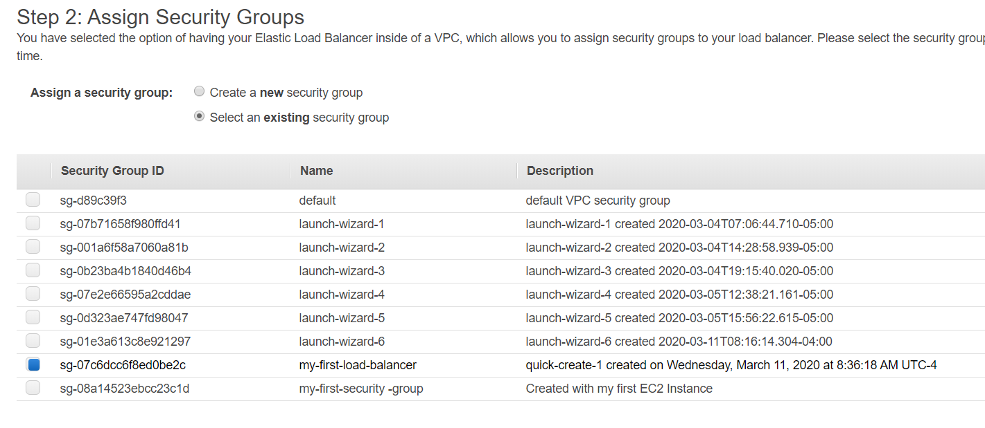

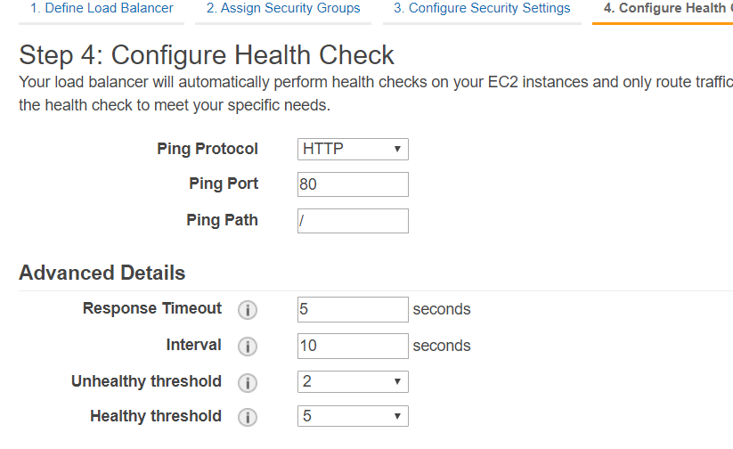

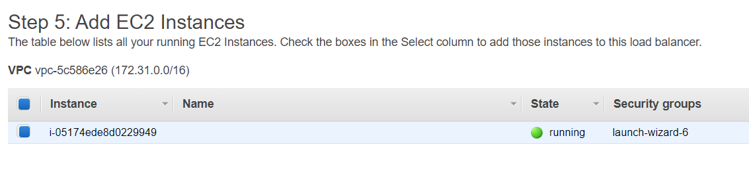

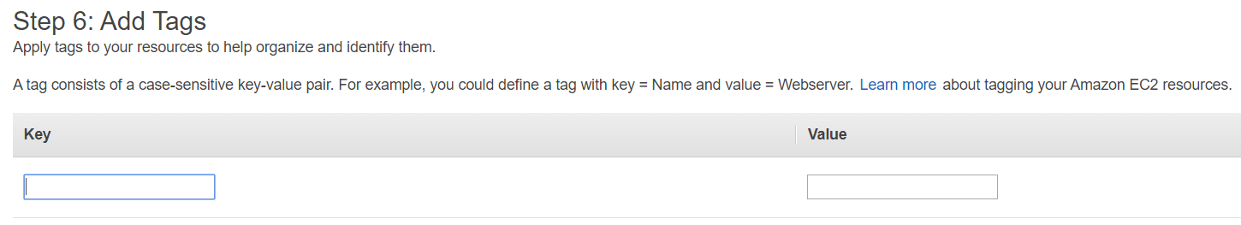

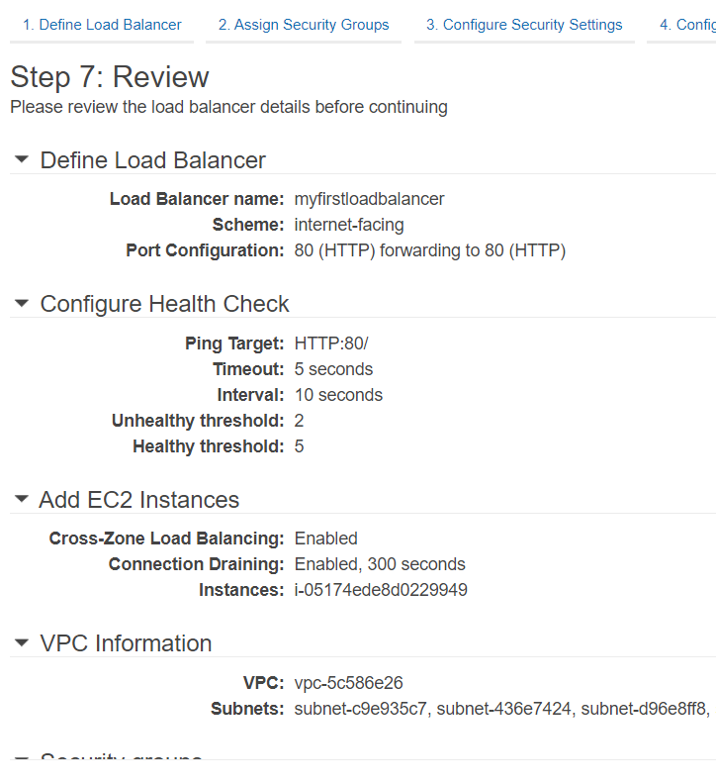

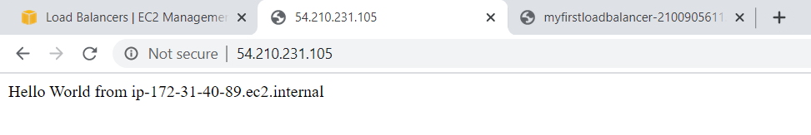

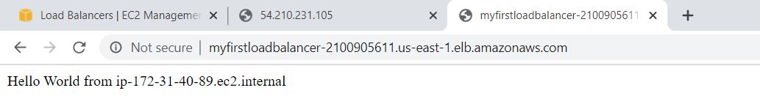

Now from both public IP and loadbalancer we are able to access to the web server. We need to make the server access only through the load balancer but not from everyother IP. WE don’t want to expose our IP address to the public.

For that

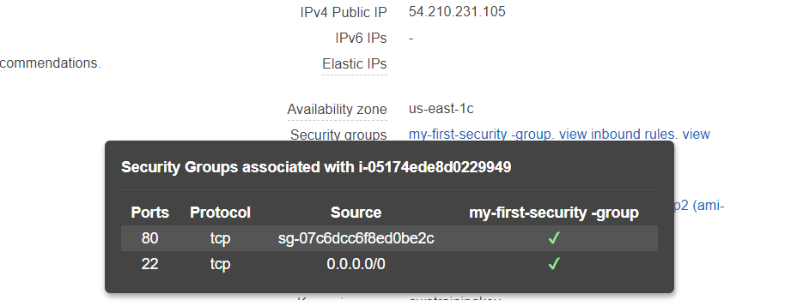

Time out issue because now only load balancer can access to the server.

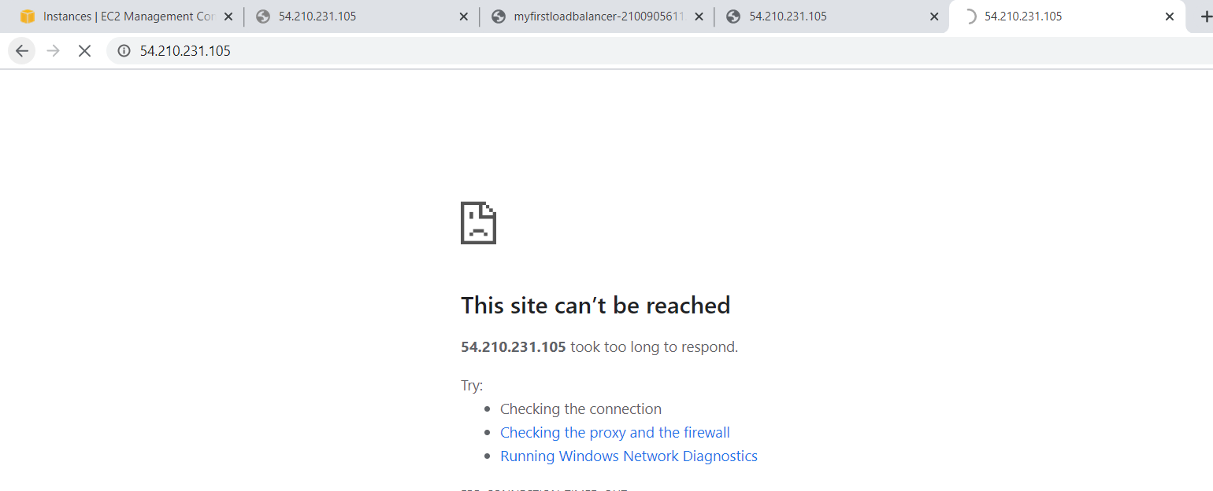

Now creating more instances.

By making right click on running instance and clicking on “more like this”.

On second copy of same instance, we have to select different aws zone in instance configuration page. Then once the different lb instance are created we have to go to load balancer and add those added instances into it.as shown below.

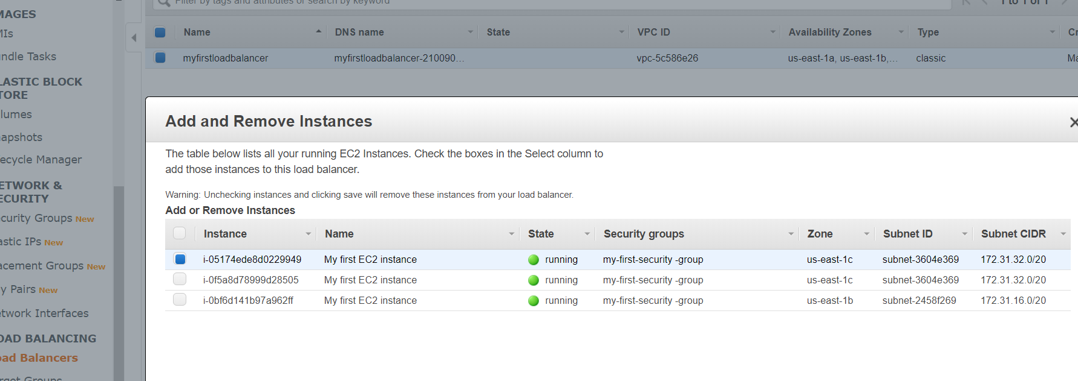

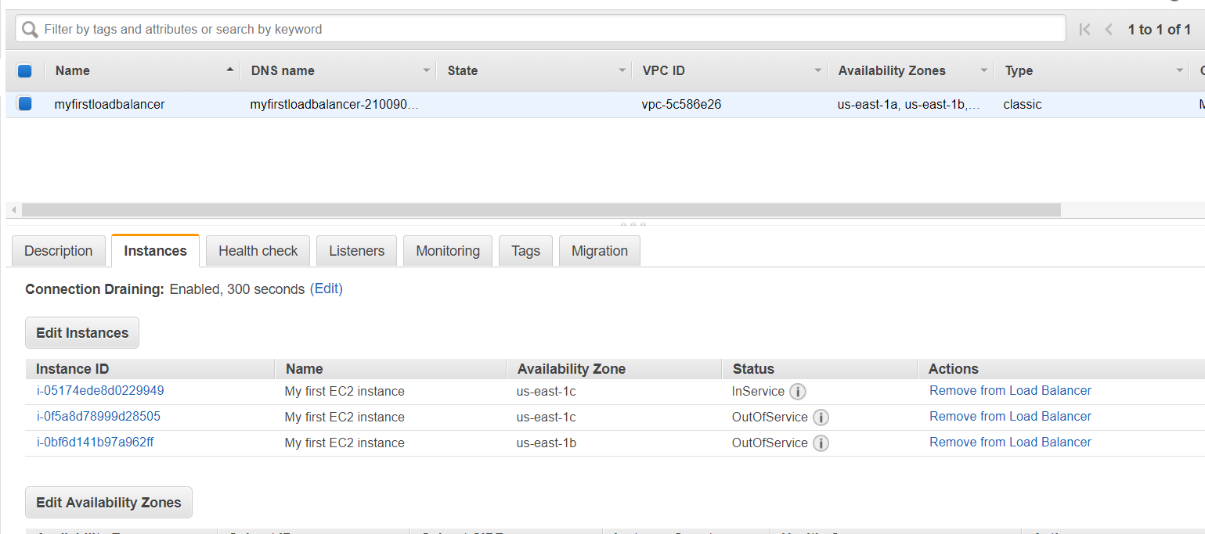

Once you create instances, you should create more of them clicking to the button “more like this”. This need various careful examination of security rule. Those instances should have differenct availability zone using the same security group and key. Once created we should move toward load balancer section.

**Now creating Application Load Balancer**

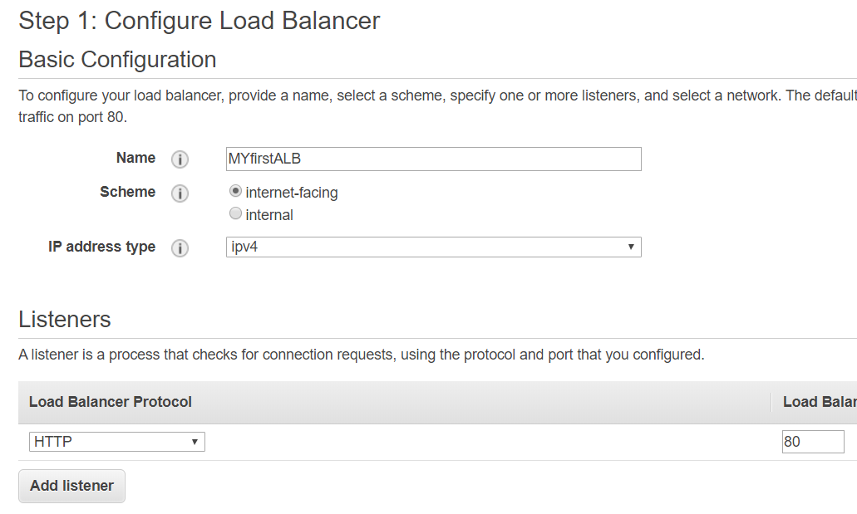

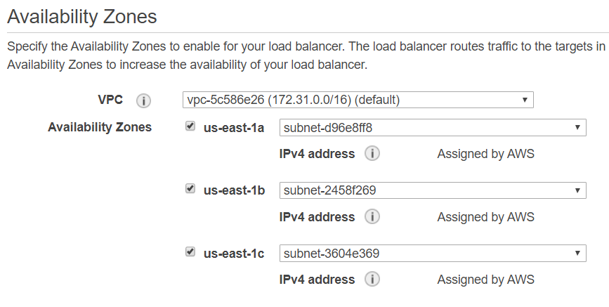

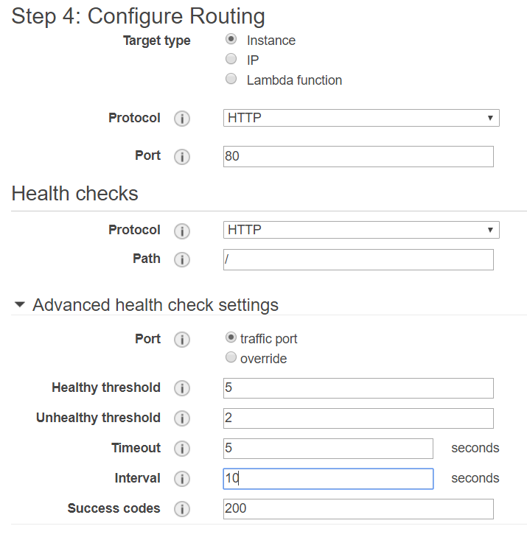

Here make sure to click on add to registered button otherwise it will return 503 error.

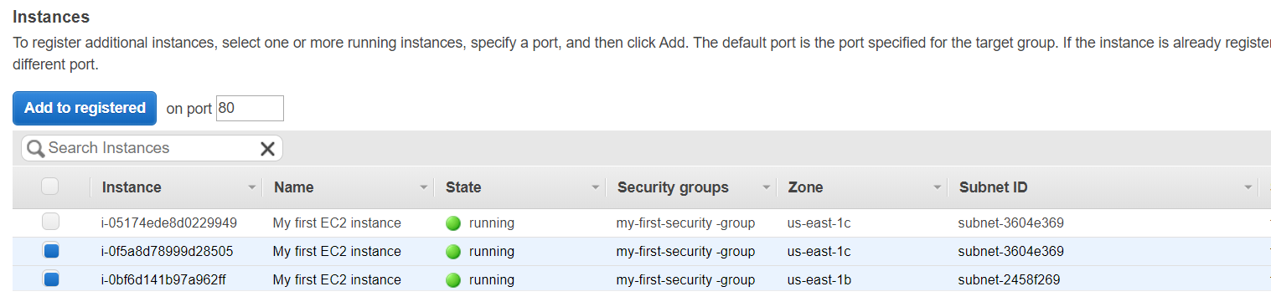

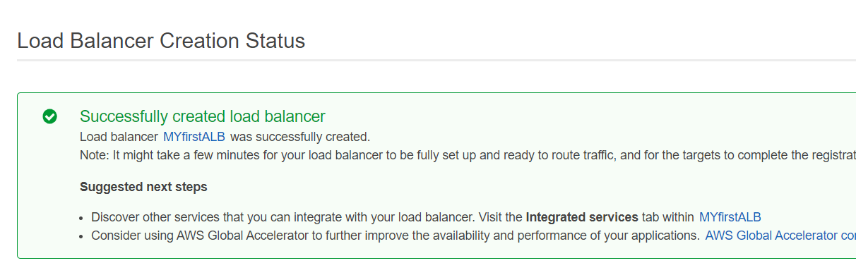

Once I created Application load balancing instance I copied my DNS url and browsed to browser but it gave an error. This was because I did not add target group to the instances. So going to the target group one can add the group to the instances.

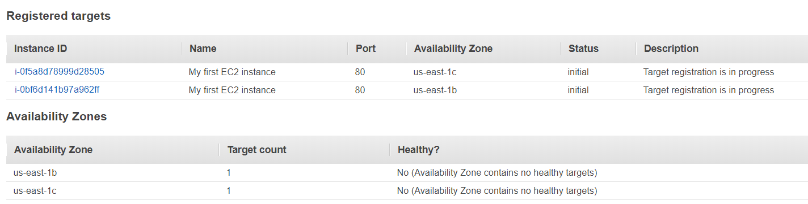

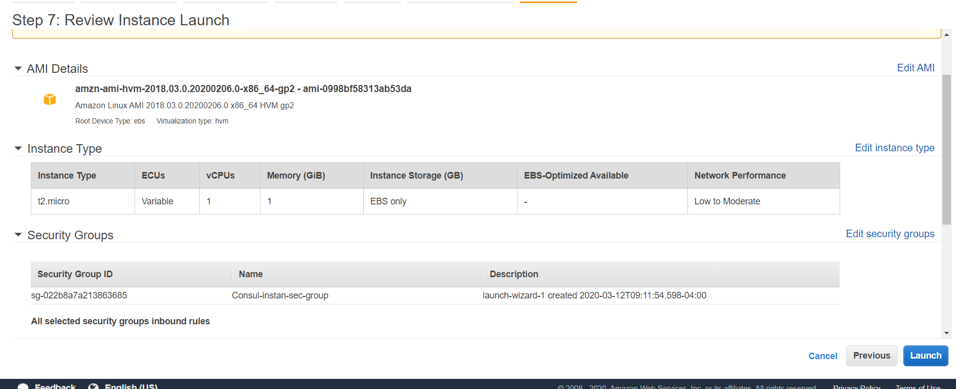

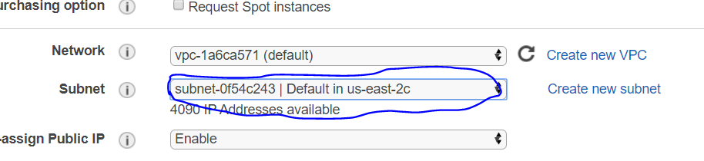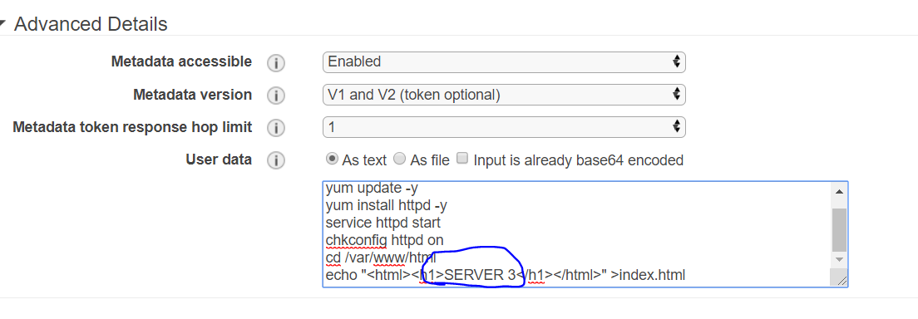



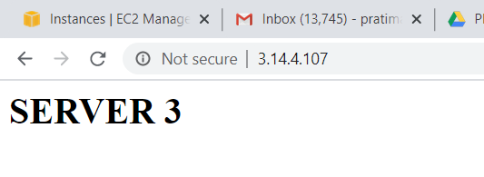

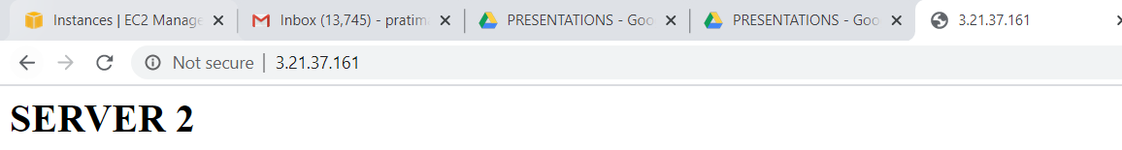

Now during creating load balancer,

Now, in this situation same port number is repeated multiple time which should not be done. Otherwise this will create an error.

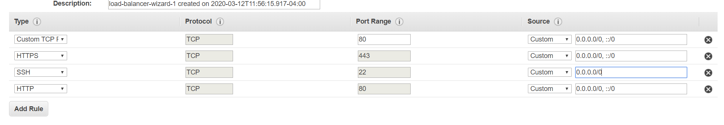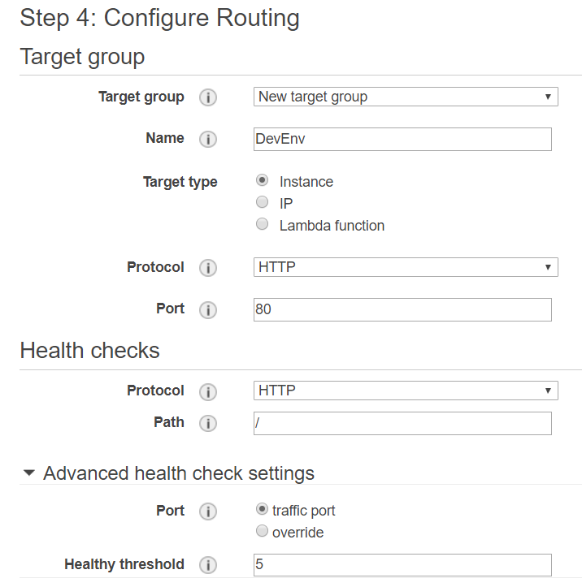

Make sure to add target clicking “add to register”.

Also make sure to delete double ports open.

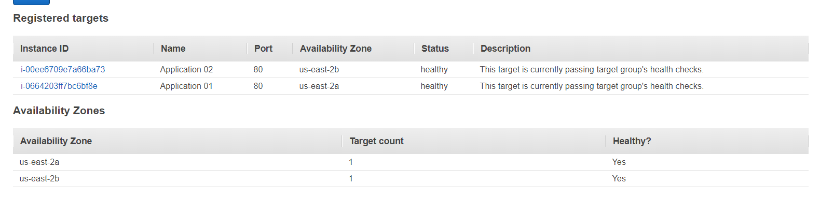

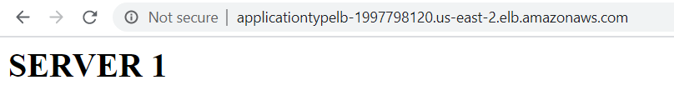

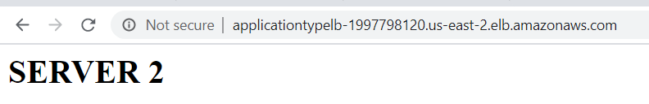



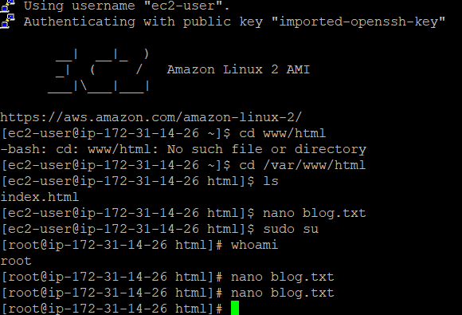

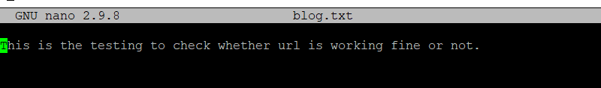

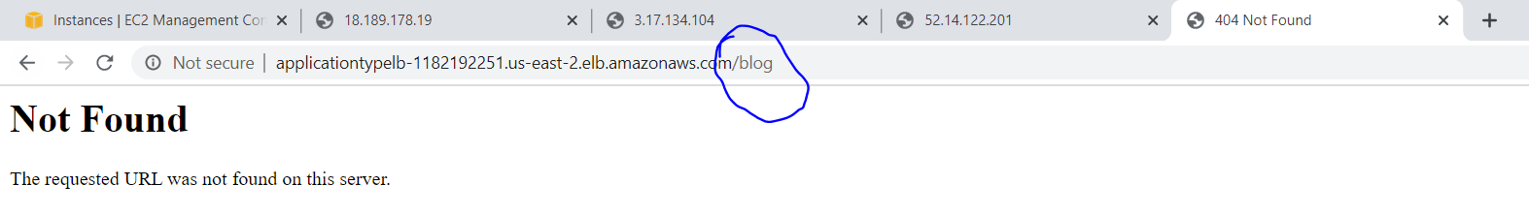

Here

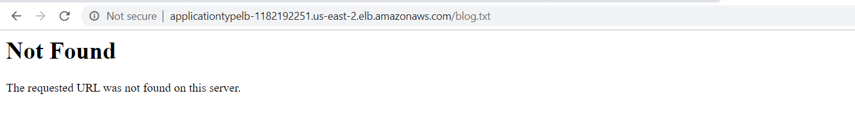

One url can be managed in multiple ways.



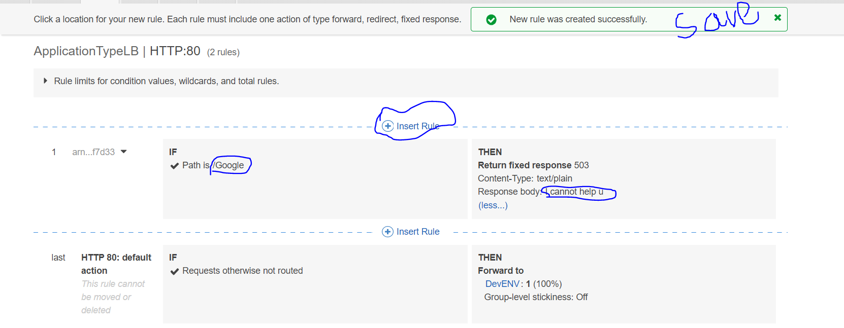

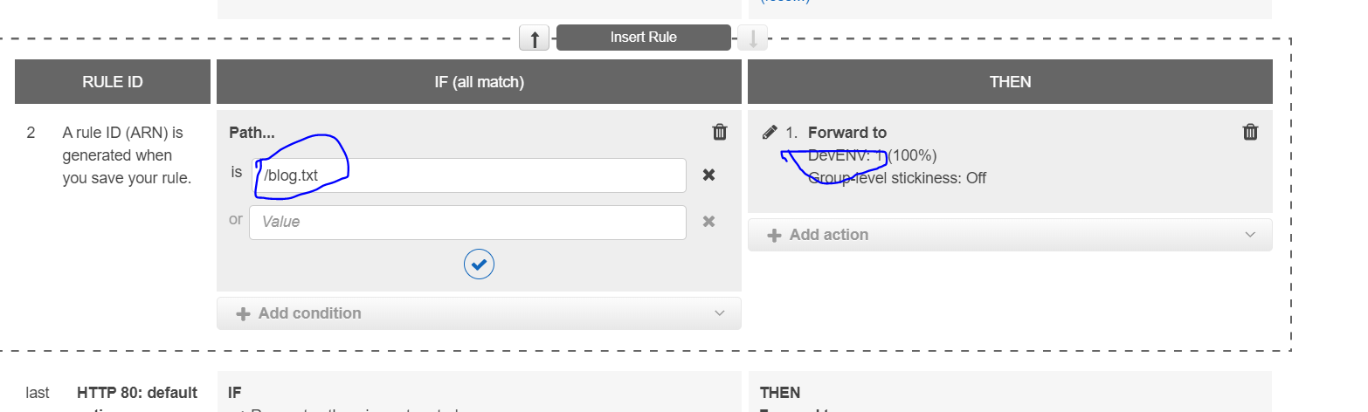

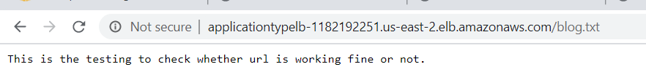

Now the target group(Production) became healthy only when we added a rule to the load balancer listener.

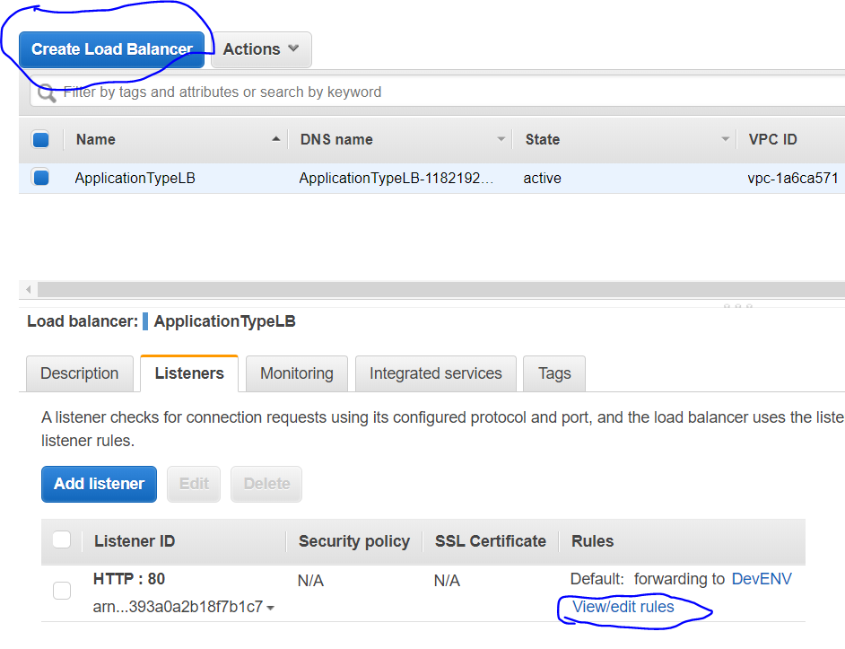

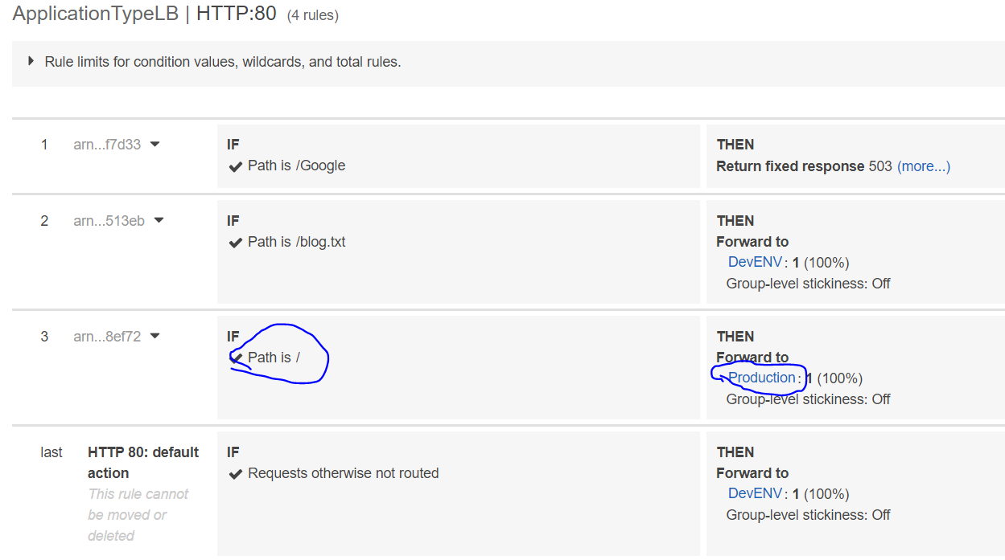

This is for production target. It will only get access to this server now.

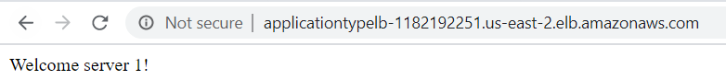

We can add another Instance machine to production target and see the difference.

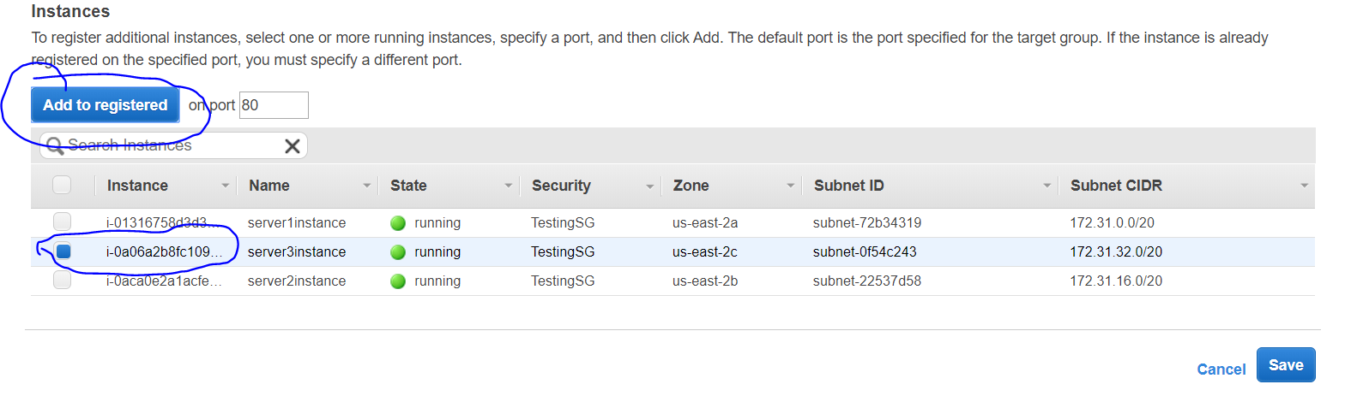

After this browing in the browser, we can now see server 1 and server 3 together.

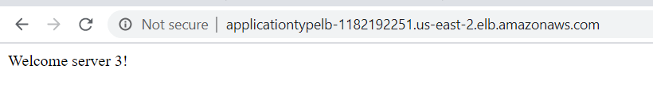

Here I created google.txt file so that I can use it.

